Development Conventions
This document summarizes the development conventions to be used with VSXtra.

Spacing and Indentation
VSXtra source files use indentation units of two spaces instead of default 4, because of publication reasons as many code details are copied and pasted into online blog entries or documents. So spacing and indentation should be set as the following figure indicates:
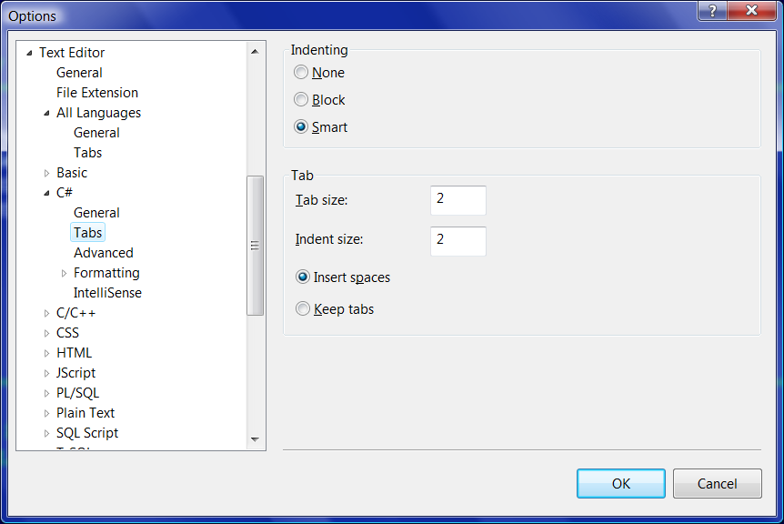

Comments
This section describes the most important guides for commenting.
Comment sections should have separation lines in order to improve readability when printing or browsing through code:
// --- Separation line for file header and type-level comments:
// ========================================================================================

// --- Separation line for member-level comments:
// ----------------------------------------------------------------------------------------

Each source file should have a header comment with the file name and the name of creator. Example:
// ========================================================================================
// PackageBase.cs
//
// Created: 2008.06.29, by Istvan Novak (DeepDiver)
// ========================================================================================
If there are relevant changes affecting functionality a source file originally created by someone else after the source was released, the header comment should indicate this. Example:
// ========================================================================================
// OutputWindow.cs
//
// Created: 2008.06.29, by Istvan Novak (DeepDiver)
//
// History:
// 2009.01.07, by Feng, SiteManager built in
// ========================================================================================
Types and type members should be commented in a style helping to understand what they are intended for and what they do. Example:
// ========================================================================================
/// <summary>
/// This static class is responsible for obtaining built-in output window pane and
/// managing (creating, obtaining and deleting) window panes through output pane
/// definition types.
/// </summary>
// ========================================================================================
public static class OutputWindow
{
// ...

// --------------------------------------------------------------------------------------
/// <summary>
/// This property defines how output pane management exceptions should be handled.
/// </summary>
// --------------------------------------------------------------------------------------
public static MissingOutputPaneHandling MissingOutputPaneHandling
{
// ...
}

// ...
}

Source File Structure
Source files should be named according to their function.
- If they contain a single type, that type name is suggested.
- If they contain more than one type with a main type and satellite types, the main type name is suggested.
- If they contain more than one type without a respectable main type, a common name should be used that covers the group of types in the file.
Avoid nested namespaces if possible.
Avoid using clauses within namespaces, if possible put them into beginning of the file.

